**Task 2**  
it would print everything from the string  
>>>print(pangram[:])  
The quick brown fox jumps over the lazy dog!

**Task 3**

1. The variable, name, does not have a 4th character  
   you cant change a character in variable like that
2. The programmer was probably trying to change the variable name = “Mary” to name = “Mark”

**Task 4**

1. ‘LeavingCertificateComputerScience’
2. ‘Thefox jumps over the lazy dog!’
3. ‘Enter a singular noun: banana

The plural of banana is bananas’

**Task 5**  
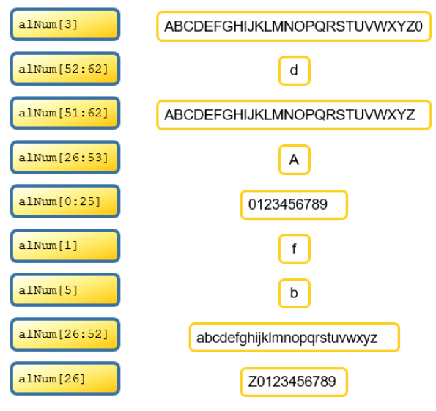

**Task 6**   
2 + 2 = 4  
**Task 7**  
3  
3  
3  
error

**Task 8**

1. Hi Hal. How are you?